**CSS VALIDATION RESULT**

My CSS document is validated by using W3.org <https://jigsaw.w3.org/css-validator/#validate_by_upload>

**RESULT DETAILS:**

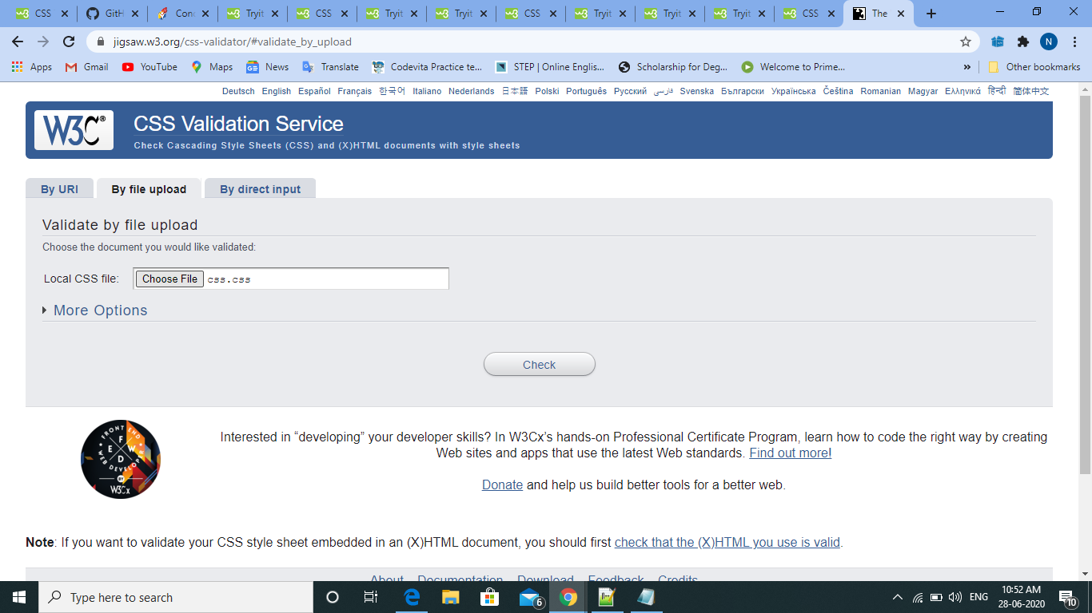

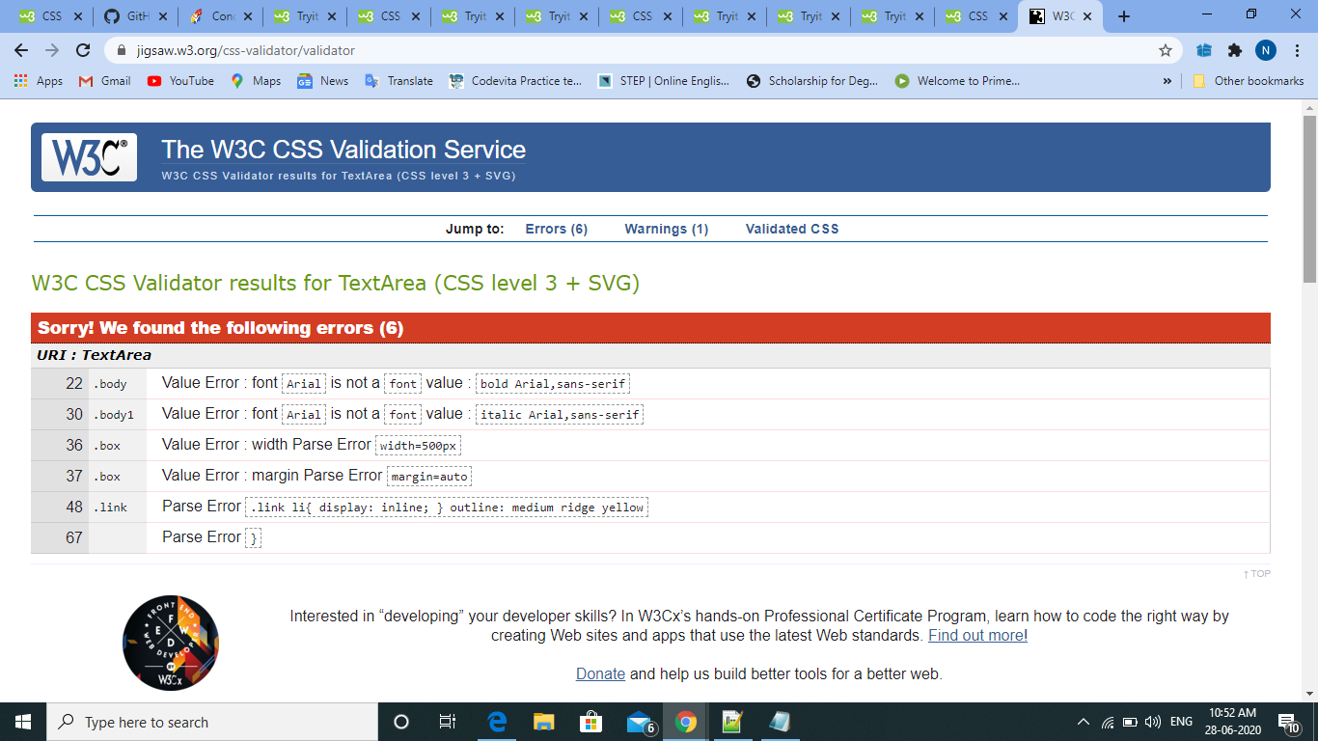

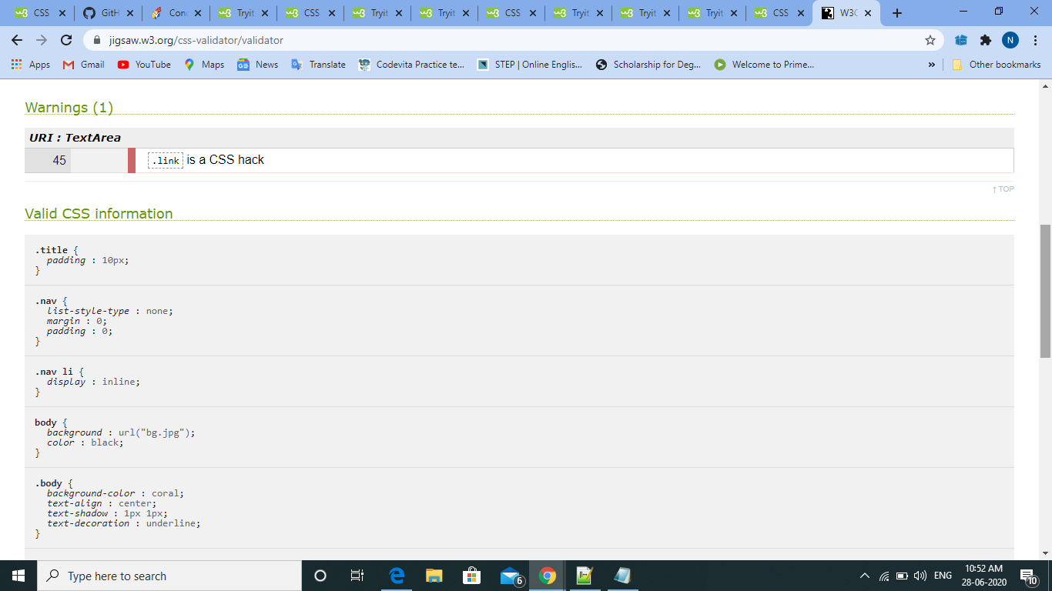

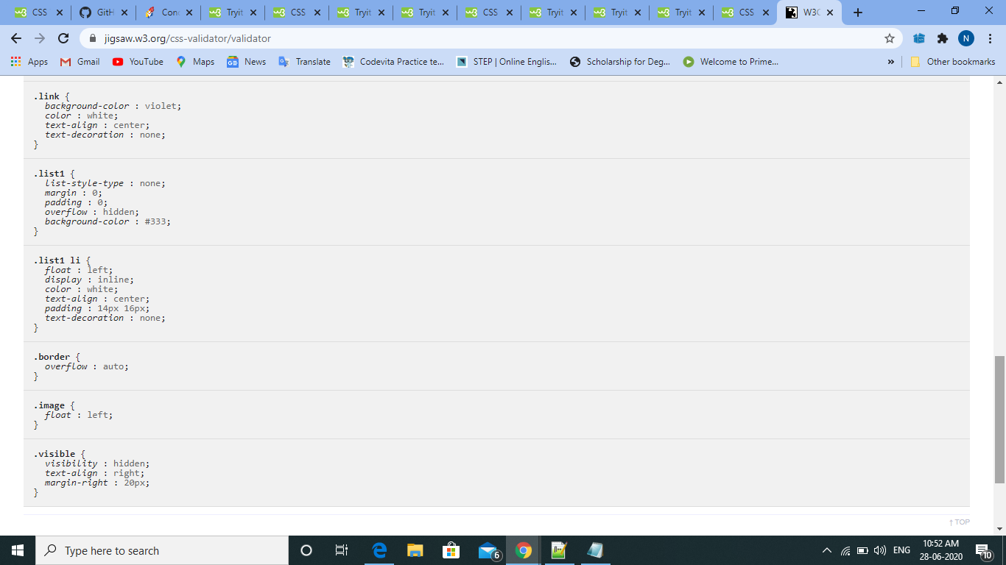

By,

Naveen Kumar S